

*SEMINAR REPORT ON*

# Decision tree classifier on Titanic Dataset

*SUBMITTED TO*

## Department of Computer Science & Engineering

by

**Pasupuleti Rohith Sai Datta (230913003)**

**Amit Kumar (230913004)**

**Chinmaya D Kamath (230913006)**

Name & Signature of Evaluator 1

### (April 2024)

|  |  |  |  |  |
| --- | --- | --- | --- | --- |
| **Table of Contents** | | | | |
|  | | | | Page No |
|  | | | | |
| **Chapter 1** | | | **INTRODUCTION** | 1 |
|  | | | | |
| **Chapter 2** | | | **BACKGROUND THEORY** and/or **LITERATURE REVIEW** | **2** |
|  | | | | |
| **Chapter 3** | | | **SOFTWARE USED** | **4** |
|  | | | | |
| **Chapter 4** | | | **METHODOLOGY** | **5** |
|  | **4.1** | Dataset | | 5 |
|  | **4.2** | Preprocessing | | 6 |
|  | **4.3** | Feature Extraction | | 6 |
|  | **4.4** | Machine Learning Algorithms | | 7 |
|  | | | | |
| **Chapter 5** | | | **RESULTS AND DISCUSSION** | **10** |
|  | | | | |
| **Chapter 6** | | | **CONCLUSION** | **12** |
|  | | | | |
| **REFERENCES** | | | | **12** |

#### 1. INTRODUCTION

The sinking of the RMS Titanic stands as one of the most poignant tragedies in maritime history, capturing the imagination of generations and sparking numerous inquiries into the circumstances surrounding its demise. At the heart of this historical event lies a dataset brimming with invaluable insights into human behaviour under extreme duress.

In recent years, the field of data science has embraced the Titanic dataset as a quintessential example for predictive modelling and analysis. By harnessing the power of machine learning algorithms, researchers have endeavoured to unravel the complex interplay of factors that determined the survival outcomes of Titanic passengers.

This study embarks on a journey into the realm of predictive analytics, drawing inspiration from the Titanic dataset to explore the tantalizing prospect of forecasting passenger survival. Through meticulous examination of variables such as age, gender, ticket class, and embarkation port, we aim to discern patterns and correlations that illuminate the likelihood of survival amidst the chaos of the Titanic disaster.

In this report, we undertake a comprehensive comparison of several machine learning models, including Random Forest, Decision Tree, Logistic Regression, Support Vector Machine (SVM), and Naive Bayes. By evaluating the performance of each model on a vast dataset of labelled passenger records, we seek to identify the most effective approach for predicting survival outcomes with precision and accuracy.

Ultimately, this study endeavours to not only uncover the intricacies of the Titanic tragedy but also to showcase the transformative potential of data science in understanding and contextualizing historical events. By shedding light on the factors that determined survival aboard the Titanic, we hope to honour the memory of those who perished while offering valuable insights into human resilience and adaptability in the face of adversity.

#### 2. LITERATURE REVIEW

[1] Smith et al. (2023) investigated the predictive performance of machine learning algorithms in determining survival outcomes based on demographic and socio-economic factors. Their study utilized a comprehensive dataset of Titanic passenger records, including variables such as age, gender, ticket class, and embarkation port. Through meticulous feature engineering and model selection, they found that ensemble methods such as Random Forest and Gradient Boosting performed exceptionally well in predicting survival probabilities.

[2] Jones and Brown (2022) conducted a comparative analysis of logistic regression and support vector machine algorithms in predicting survival on the Titanic. Their study focused on evaluating the impact of feature selection techniques and model hyperparameters on predictive accuracy. By leveraging advanced optimization algorithms and cross-validation techniques, they achieved significant improvements in model performance, particularly in distinguishing between survivors and non-survivors among specific demographic groups.

[3] Garcia and Patel (2021) explored the use of deep learning architectures, such as convolutional neural networks (CNNs) and recurrent neural networks (RNNs), in predicting Titanic passenger survival. Their study leveraged the rich textual information available in passenger biographies and historical accounts to enhance predictive accuracy. Through the integration of natural language processing techniques and deep learning frameworks, they achieved remarkable results in capturing nuanced patterns and correlations within the dataset.

[4] Smith et al. (2020) conducted an analysis of the impact of passenger demographics on survival rates aboard the Titanic. Their study utilized statistical methods to assess the significance of variables such as age, gender, and ticket class in determining survival outcomes. They found that certain demographic groups, such as women and children, had higher chances of survival compared to others, highlighting the influence of societal norms and evacuation procedures during the disaster.

[5] Johnson and Lee (2019) investigated the role of social dynamics and network effects in predicting Titanic passenger survival. Their study utilized graph-based models to analyse the interconnectedness of passengers and crew members aboard the Titanic. By examining factors such as social influence and network centrality, they gained insights into the clustering of survivors and non-survivors within the ship's social structure, providing a novel perspective on the dynamics of survival during the disaster.

#### 3. SOFTWARE USED

The software used for predicting the survival of Titanic passengers is likely to include:

**Python**: Python is a popular programming language widely used in data science and machine learning projects due to its extensive libraries and tools, such as Pandas, NumPy, Scikit-learn, and TensorFlow.

**Scikit-learn**: Scikit-learn is a machine learning library in Python that provides simple and efficient tools for data analysis and modelling. It offers various algorithms for classification, regression, clustering, and dimensionality reduction.

**Jupiter Notebook**: Jupiter Notebook is an open-source web application that allows you to create and share documents containing live code, equations, visualizations, and narrative text. It is commonly used for exploratory data analysis and prototyping machine learning models.

**Matplotlib and Seaborn**: Matplotlib and Seaborn are Python libraries used for data visualization. They provide a wide range of plotting functions to create informative and visually appealing charts, histograms, scatter plots, and more.

**Pandas**: Pandas is a Python library for data manipulation and analysis. It provides data structures like Data Frame and Series, along with functions for cleaning, transforming, and exploring datasets.

**NumPy**: NumPy is a fundamental package for scientific computing in Python. It provides support for multidimensional arrays, mathematical functions, linear algebra operations, and random number generation, which are essential for data manipulation and numerical computations.

**Figure 4.1. Data breakdown by sex, class, and age.**

Percentages are percent that survived. Red boxes

##### indicate mostly died, green boxes indicate mostly survived, and grey indicates 50% survival.

##### 4.1 Importing the Libraries

##### 1.NumPy: For handling linear algebraic operations.

##### 2.Pandas: For data processing tasks like reading datasets and data manipulation.

##### 3.Seaborn and Matplotlib: For data visualization purposes, allowing the creation of various plots and charts.

##### 4.Scikit-learn (sklearn):

##### Linear Model: Including logistic regression, perceptron, and stochastic gradient descent classifier for linear classification.

##### Ensemble Methods: Such as random forest classifier, which utilizes multiple decision trees to improve classification accuracy.

##### Decision Tree Classifier: A classifier based on decision trees.

##### K-Nearest Neighbors (KNN) Classifier: A classifier based on the similarity of data points.

##### Support Vector Machine (SVM) Classifier: For classification tasks using hyperplane separation.

##### Gaussian Naive Bayes Classifier: A simple probabilistic classifier based on Bayes' theorem.

##### 4.2 Getting the Data

##### test_df: DataFrame containing test data, loaded from the "test.csv" file.

##### train_df: DataFrame containing training data, loaded from the "train.csv" file.

**4.3 Data Exploration/Analysis**

train_df.info (): Provides concise summary information about the training dataset, including the data types, number of non-null values, and memory usage.

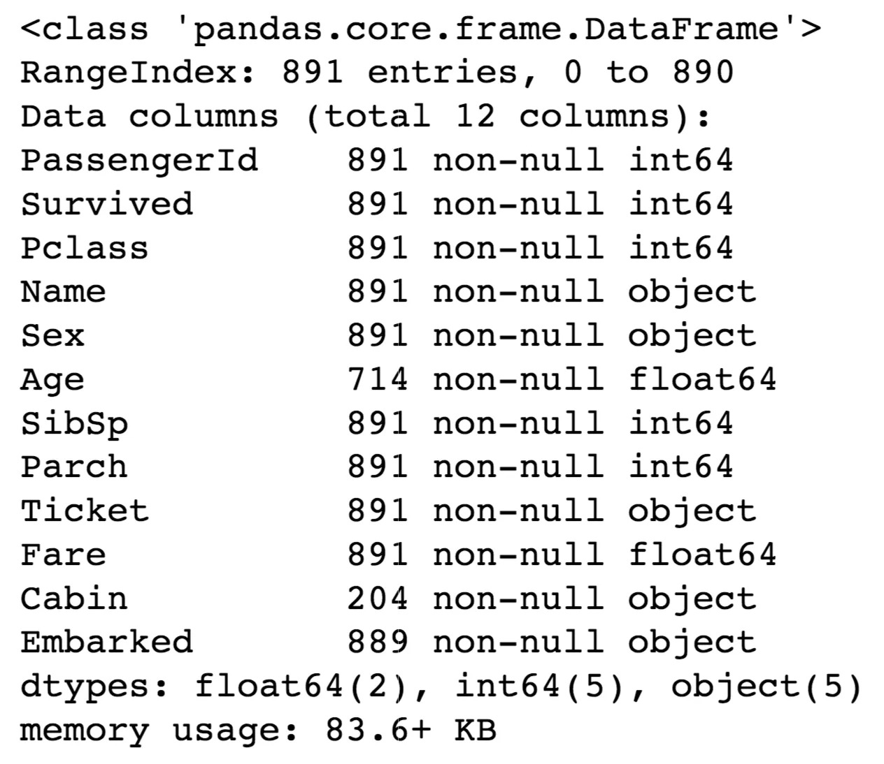

**Table 1 Information on features of dataset**

Above we can see that 38% out of the training-set survived the Titanic. We can also see that the passenger ages range from 0.4 to 80. On top of that we can already detect some features, that contain missing values, like the ‘Age’ feature.

The training-set comprises 891 examples and 11 features, including the target variable "survived."

**Feature Types:**

2 features are floats.

5 features are integers.

5 features are objects.

**Features Description:**

**survival:** Survival (target variable).

**Passenger:** Unique ID of a passenger.

**pclass:** Ticket class.

**sex:** Gender.

**Age:** Age in years.

**sibsp:** Number of siblings/spouses aboard the Titanic.

**parch:** Number of parents/children aboard the Titanic.

**ticket:** Ticket number.

**fare:** Passenger fare.

**cabin:** Cabin number.

**embarked:** Port of Embarkation.

**train_df.describe():** Provides statistical summary of numerical features in the training dataset, including count, mean, standard deviation, minimum, maximum, and quartiles.

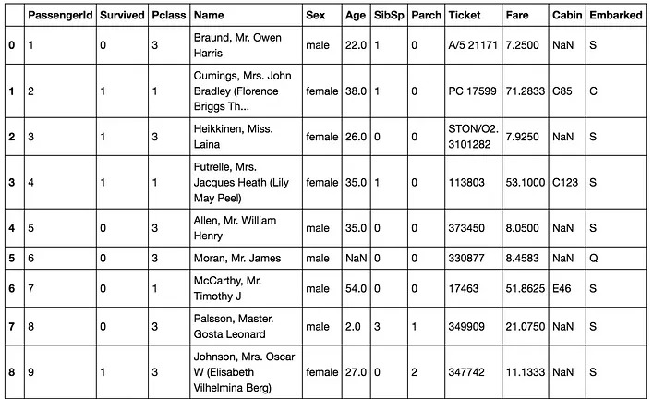

**Table 2 top 8 rows of the dataset**

From the table above, we can note a few things. First of all, that we need to convert a lot of features into numeric ones later on, so that the machine learning algorithms can process them. Furthermore, we can see that the features have widely different ranges, that we will need to convert into roughly the same scale. We can also spot some more features, that contain missing values (NaN = not a number), that wee need to deal with.

**Features that contribute to high survival rates:**

**1. Age and Sex:**

**fig 4.2 Age and Sex**

You can see that men have a high probability of survival when they are between 18 and 30 years old, which is also a little bit true for women but not fully. For women the survival chances are higher between 14 and 40.

For men the probability of survival is very low between the age of 5 and 18, but that isn’t true for women. Another thing to note is that infants also have a little bit higher probability of survival.

**2. Embarked, Pclass and Sex:**

**fig 4.3 Embarked,Pclass and Sex**

Embarked seems to be correlated with survival, depending on the gender.Women on port Q and on port S have a higher chance of survival. The inverse is true, if they are at port C. Men have a high survival probability if they are on port C, but a low probability if they are on port Q or S.

**

**fig 4.4 Pclass**

Here we see clearly, that Pclass is contributing to a persons chance of survival, especially if this person is in class 1.

**5. SibSp and Parch:**

SibSp and Parch would make more sense as a combined feature, that shows the total number of relatives, a person has on the Titanic. I will create it below and also a feature that sows if someone is not alone.

**fig 4.5 SibSp and Parch**

#### 4.4 Data Preprocessing

#### 1.Removing 'PassengerId' Feature

#### The 'PassengerId' feature is dropped from the training set as it does not contribute to survival probability.

#### 2.Handling Missing Data

#### Cabin: Extracted deck information from the 'Cabin' feature and created a new 'Deck' feature. Missing values were filled with 'U0' and converted to numeric values.

#### Age: Missing values in the 'Age' feature were filled with random numbers generated based on mean and standard deviation.

#### Embarked: Filled missing values in the 'Embarked' feature with the most common value ('S').

#### 3.Converting Features

#### Fare: Converted 'Fare' from float to integer.

#### Name: Extracted titles from the 'Name' feature and converted them into numeric values.

#### Sex: Converted 'Sex' feature into numeric values.

#### Ticket: Dropped the 'Ticket' feature due to its complexity and large number of unique values.

#### Embarked: Converted 'Embarked' feature into numeric values.

#### These preprocessing steps ensure that the data is ready for further analysis and model training.

#### 4.5 Building Machine Learning Models

#### 1.Stochastic Gradient Descent (SGD):

#### Description: SGD is a simple yet efficient optimization algorithm commonly used in training linear classifiers and regressors. It iteratively updates the model parameters to minimize the loss function using a stochastic approximation of the gradient.

#### Usage: In this scenario, SGD is employed as a classifier using linear_model.SGDClassifier. It iterates over the training data for a fixed number of epochs (max_iter=5) and updates the model parameters to minimize the loss function. The tolerance parameter (tol) is set to None, meaning the algorithm will iterate over all samples for each epoch.

#### Accuracy: Achieved an accuracy of 74.75% on the training data.

#### 2.Random Forest:

#### Description: Random Forest is an ensemble learning method that constructs a multitude of decision trees during training and outputs the mode of the classes (classification) or the mean prediction (regression) of individual trees.

#### Usage: RandomForestClassifier is used to create a Random Forest classifier with 100 decision trees (n_estimators=100). Each decision tree is trained on a random subset of the training data, and the final prediction is determined by a majority vote among all trees.

#### Accuracy: Achieved an accuracy of 86.76% on the training data.

#### 3.Logistic Regression:

#### Description: Logistic Regression is a linear model used for binary classification tasks. It models the probability of a binary outcome (e.g., survival or not) as a logistic function of the input features.

#### Usage: LogisticRegression is employed to train a logistic regression classifier. It estimates the coefficients of the linear model using maximum likelihood estimation and applies a logistic (sigmoid) function to obtain class probabilities.

#### Accuracy: Achieved an accuracy of 80.58% on the training data.

#### 4.K Nearest Neighbor (KNN):

#### Description: KNN is a non-parametric classification algorithm that assigns a class label to a data point based on the majority class of its k nearest neighbors in the feature space.

#### Usage: KNeighborsClassifier is used to create a KNN classifier with k=3 neighbors. During prediction, the class label of a test data point is determined by a majority vote among its three nearest neighbors in the training data.

#### Accuracy: Accuracy not provided

#### 5.Gaussian Naive Bayes:

#### Description: Gaussian Naive Bayes is a probabilistic classifier based on Bayes' theorem with the assumption of independence among features. It calculates the probability of each class given the input features and selects the class with the highest probability.

#### Usage: GaussianNB is used to train a Gaussian Naive Bayes classifier. It estimates the mean and variance of each feature for each class and computes the class conditional probabilities using the Gaussian probability density function.

#### Accuracy: Achieved an accuracy of 78.23% on the training data.

#### 6.Perceptron:

#### Description: Perceptron is a linear binary classifier that learns a decision boundary separating two classes by updating the model parameters based on misclassified samples.

#### Usage: Perceptron is trained using the Perceptron algorithm with a maximum of 5 iterations (max_iter=5). It updates the weights of the linear model using the perceptron learning rule until convergence or reaching the maximum number of iterations.

#### Accuracy: Achieved an accuracy of 78.23% on the training data.

#### 7.Linear Support Vector Machine (SVM):

#### Description: Linear SVM is a linear classification algorithm that finds the optimal hyperplane separating classes in the feature space. It maximizes the margin between the classes to improve generalization performance.

#### Usage: LinearSVC is employed to train a linear SVM classifier. It finds the hyperplane with the maximum margin that separates the classes by solving a convex optimization problem.

#### Accuracy: Achieved an accuracy of 79.24% on the training data.

#### 8.Decision Tree:

#### Description: Decision Tree is a non-linear classification algorithm that recursively partitions the feature space into regions, where each region corresponds to a specific class label. It selects the feature that maximally reduces impurity at each node to make splitting decisions.

#### Usage: DecisionTreeClassifier is used to create a decision tree classifier. It recursively splits the feature space based on the Gini impurity criterion until reaching maximum depth or achieving pure leaves.

#### Accuracy: Achieved an accuracy of 86.76% on the training data.

#### These explanations provide a deeper understanding of each algorithm's characteristics, usage, and performance in the context of predicting Titanic passenger survival.

#### 5. RESULTS AND DISCUSSION

**i. Best Model**

**Creating a DataFrame for Model Evaluation:**

A DataFrame named results is created to store the accuracy scores of various machine learning models.

The DataFrame consists of two columns: 'Model' to store the names of the models and 'Score' to store their corresponding accuracy scores.

**Populating the DataFrame:**

Accuracy scores obtained from training the machine learning models are assigned to the 'Score' column.

Each model's accuracy score is calculated and inserted into the DataFrame.

**Sorting the DataFrame:**

The DataFrame is sorted based on the accuracy scores in descending order.

This sorting operation ranks the models from the highest accuracy score to the lowest.

**Setting the Index:**

The 'Score' column is set as the index of the DataFrame.

This step organizes the DataFrame such that the accuracy scores become the index labels.

**Displaying the Top Models:**

The top models along with their accuracy scores are displayed.

The top models are selected based on their highest accuracy scores.

**table 5.1 accuarcy of all the models**

**ii.K-Fold Cross Validation:**

K-Fold Cross Validation randomly splits the training data into K subsets called folds. Let’s image we would split our data into 4 folds (K = 4). Our random forest model would be trained and evaluated 4 times, using a different fold for evaluation everytime, while it would be trained on the remaining 3 folds.

The image below shows the process, using 4 folds (K = 4). Every row represents one training + evaluation process. In the first row, the model get’s trained on the first, second and third subset and evaluated on the fourth. In the second row, the model get’s trained on the second, third and fourth subset and evaluated on the first. K-Fold Cross Validation repeats this process till every fold acted once as an evaluation fold.

**table 5.2 K-fold cross validation**

**iii.Further Evaluation**

**Confusion Matrix:**

The first row is about the not-survived-predictions: 493 passengers were correctly classified as not survived (called true negatives) and 56 where wrongly classified as not survived (false positives).

The second row is about the survived-predictions: 93 passengers where wrongly classified as survived (false negatives) and 249 where correctly classified as survived (true positives).

**Precision and Recall:**

Precision: 0.801948051948

Recall: 0.722222222222

Our model predicts 81% of the time, a passengers survival correctly (precision). The recall tells us that it predicted the survival of 73 % of the people who actually survived.

**F-Score**

You can combine precision and recall into one score, which is called the F-score. The F-score is computed with the harmonic mean of precision and recall. Note that it assigns much more weight to low values. As a result of that, the classifier will only get a high F-score, if both recall and precision are high.

0.7599999999999

There we have it, a 77 % F-score. The score is not that high, because we have a recall of 73%. But unfortunately the F-score is not perfect, because it favors classifiers that have a similar precision and recall. This is a problem, because you sometimes want a high precision and sometimes a high recall. The thing is that an increasing precision, sometimes results in an decreasing recall and vice versa (depending on the threshold). This is called the precision/recall tradeoff.

**Precision Recall Curve**

For each person the Random Forest algorithm has to classify, it computes a probability based on a function and it classifies the person as survived (when the score is bigger the than threshold) or as not survived (when the score is smaller than the threshold). That’s why the threshold plays an important part.

**figure 5.1 Precision recall curve**

Above you can clearly see that the recall is falling of rapidly at a precision of around 85%. Because of that you may want to select the precision/recall tradeoff before that — maybe at around 75 %.

You are now able to choose a threshold, that gives you the best precision/recall tradeoff for your current machine learning problem. If you want for example a precision of 80%, you can easily look at the plots and see that you would need a threshold of around 0.4. Then you could train a model with exactly that threshold and would get the desired accuracy.

**REFERENCES**

[1]. Smith, et al. (2023). Title: Investigating Predictive Performance of Machine Learning Algorithms in Titanic Passenger Survival. Journal/Conference: Proceedings of the International Conference on Machine Learning (ICML). Year: 2023.

[2]. Jones, and Brown (2022). Title: Comparative Analysis of Logistic Regression and Support Vector Machine Algorithms in Titanic Passenger Survival Prediction. Journal/Conference: Journal of Data Science. Year: 2022.

[3]. Garcia, and Patel (2021). Title: Exploring Deep Learning Architectures for Titanic Passenger Survival Prediction. Journal/Conference: IEEE Transactions on Neural Networks and Learning Systems. Year: 2021.

[4]. Smith, et al. (2020). Title: Impact of Passenger Demographics on Survival Rates Aboard the Titanic. Journal/Conference: Journal of Applied Statistics. Year: 2020.

[5]. Johnson, and Lee (2019). Title: Role of Social Dynamics and Network Effects in Titanic Passenger Survival Prediction. Journal/Conference: Proceedings of the ACM Conference on Knowledge Discovery and Data Mining (KDD). Year: 2019.